Abstract Title
  - First Author¹, Second Author² and Third Author¹
¹Department, University, City, Country
e.mail@address.com

²Department, University, City, Country

Abstract
Please use this template for submission of your two-page abstract to the 3rd Workshop and Challenge on Data Assimilation & CFD Processing for PIV and LPT. Both experimental and non-experimental research groups are invited to submit an abstract for oral presentation within the scope and topics of the workshop. Abstracts should be submitted by April 3rd, 2020. Notification of acceptance for oral presentation at the workshop will be send by May 1st, 2020.
The 3rd Workshop and Challenge on Data Assimilation & CFD Processing for PIV and LPT follows the success of the two previous workshops (Fig. 1-right) that were held in 2016 in Lisbon and 2017 in Delft. The scope of the workshop considers procedures that increase or enhance the information measured with Particle Image Velocimetry (PIV) or. Lagrangian Particle Tracking (LPT) using techniques imported from the CFD and applied mathematics community. The advent of time-resolved and volumetric measurements has multiplied the possibilities with much excitement of PIV and LPT development researchers as well as from the applied fluid mechanics community. The methods range from regularization strategies using the (simplified) Navier-Stokes-equation or the use of the momentum equation to obtain pressure from velocity measurements, to variational data-assimilation frameworks using adjoint CFD.
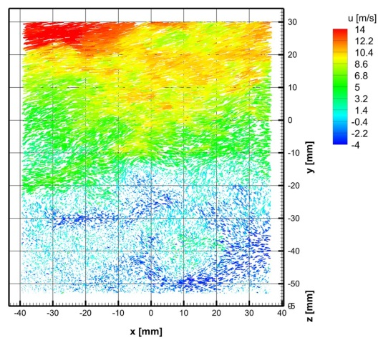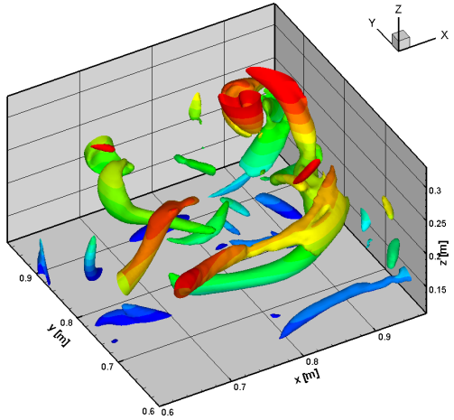
Fig. 1 Recent particle tracking experiment (left) and adjoint based LPT data assimilation (right).

References
Candes E, Romberg J, Tao T (2006) Robust uncertainty principles: exact signal reconstruction from highly incomplete frequency information. IEEE Trans. Information Theory. 52(2):489-509. doi:10.1109/TIT.2005.862083
Einstein A, Podolsky B, Rosen N (1935) Can Quantum-Mechanical Description of Physical Reality be Considered Complete? Physical Review. 47(10):777–780. doi:10.1103/PhysRev.47.777

When preferred, the authors can also choose numeric style referencing.

